Capstone Report: Price Optimization Strategy for Big Mountain Resort

Problem Statement
Big Mountain Resort may be undervaluing its adult weekend tickets compared to other North American ski resorts. This project uses a data-driven approach, cleaning, exploring, and modeling resort attributes, to determine a fair ticket price and recommend actionable changes to maximize revenue.

Data Wrangling
We combined multiple raw datasets into a unified ski resort dataset, handling:
- Missing data in snowmaking, lift capacity, and terrain
- Categorical standardization for resort names, states, and regions
- Derived features including resort density per state and ticket price comparisons
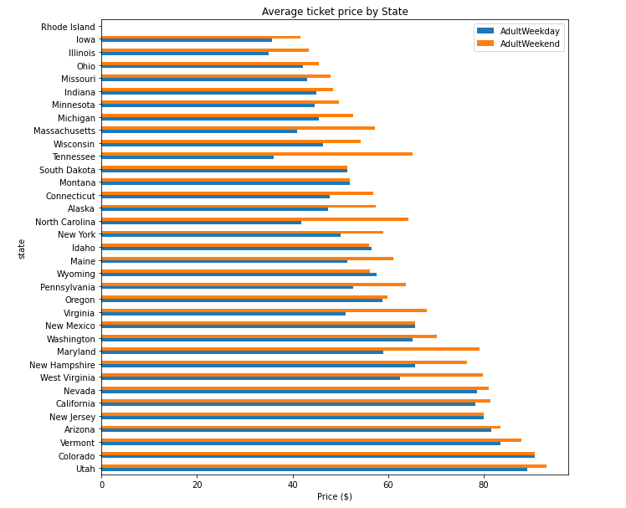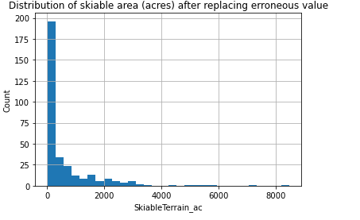

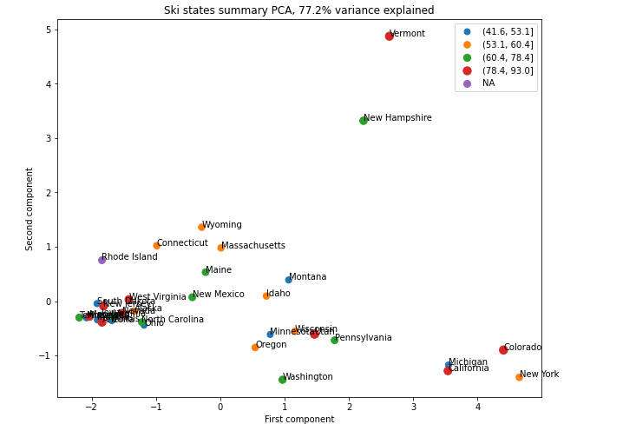
Exploratory Data Analysis (EDA)
EDA revealed strong correlations between price and features such as:
- Vertical drop
- Snowmaking area
- Number of fast quads and total lifts
- Total skiable terrain
Big Mountain showed average to strong terrain and vertical metrics, but weaker infrastructure (e.g., snowmaking, fast lifts).
Model Preprocessing and Feature Engineering
After initial model benchmarking (mean predictor, dummy regressor), we:
- Split data into training and test sets
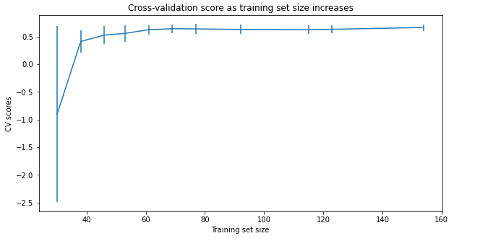
- Imputed missing values with medians
- Standardized numeric features
- Used SelectKBest to identify top predictors like vertical_drop, snowMaking_ac, and fastQuads
Model testing included:
- Linear Regression
- Ridge Regression (best performance)
- Decision Tree Regressor (overfit)
The best model showed:
- MAE ≈ $9
- R² ≈ 0.82
Modeling & Scenario Analysis (Notebook 5)
We re-trained the final model excluding Big Mountain to remove bias, then predicted its optimal price:
- Current ticket price: Below $70
- Predicted price: ~$79.50 (≈ 13% undervaluation)
Scenario analysis showed that with facility upgrades, pricing could justifiably rise:
Scenario | Change | Predicted Price
Baseline | Current facilities | $70
Add 3 fast quads | More high-speed lifts | $75
Expand snowmaking by 50% | Snow coverage ↑ | $77
Add tram & terrain | Major infrastructure | $80–82
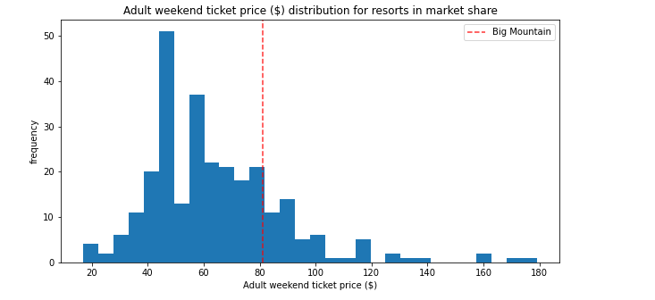

Recommendations
- Raise ticket price to $78–$80: The model justifies this based on peer offerings and attributes.
- Infrastructure investment roadmap:
  - Prioritize fast quads and snowmaking expansion
  - Long-term: tram installation and terrain expansion
- Use this model as a dynamic pricing tool as new resorts and competitors emerge.

Conclusion & Future Scope
This project demonstrates that Big Mountain is leaving potential revenue untapped. By realigning price and value, and incrementally improving facilities, the resort can capture greater market share and profitability.
Future enhancements include:
- Seasonal pricing models
- Cluster-based recommendations (e.g., by region)
- Consumer behavior data to personalize pricing strategies

